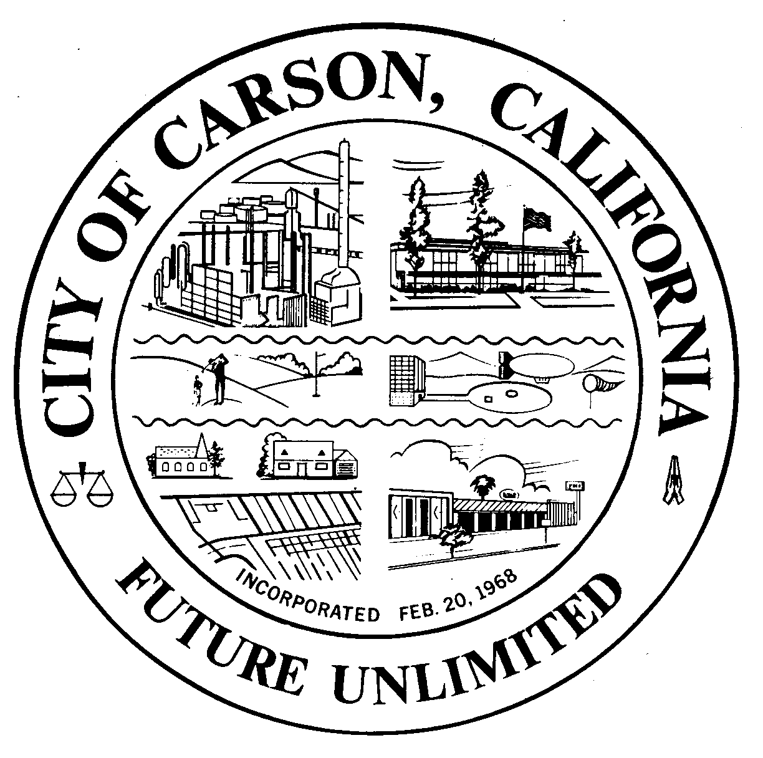
A G E N D A
CITY OF CARSON
REGULAR MEETING OF THE ENVIRONMENTAL COMMISSION
701 East Carson Street, Carson, CA 90745
EXECUTIVE CONFERENCE ROOM, 2ND FLOOR
Wednesday, March 5, 2014
6:30 p.m.

- CALL TO ORDER:

- PLEDGE OF ALLEGIANCE:

- ROLL CALL: Environmental Commissioners:
Burr, Hellerud, Hopson, Jimenez, Love, Mack, Muckey, Perry, Taylor
- AGENDA POSTING CERTIFICATION: In accordance with the Americans with
Disabilities Act of 1990, if you require a disability related modification or accommodation to attend or participate in this meeting, including auxiliary aids or services, please call the City Clerk’s office at 310-952-1720 at least 48 hours prior to the meeting. (Government Code Section 54954.2)
- AGENDA APPROVAL:
- ORAL COMMUNICATIONS: For items NOT on the agenda. Speakers are limited to three minutes.
- MINUTES APPROVAL:
  - February 5, 2014
- UNFINISHED BUSINESS
a. Environmental Commission Logo Discussions
b. Oxy Draft EIR Joint Workshop with Planning Commission
- NEW BUSINESS
  - Shell CRP Draft EIR Joint Workshop with Planning Commission
- WRITTEN COMMUNICATIONS
  - None
__________________________________________________________________
- ORAL COMMUNICATIONS
  - Audience
  - Commissioners
    - Update on the February 21, 2014 Community/HOA Workshop
  - Staff
- Participation Certificate for Ethics Training
- Ethics Training booklets for Commissioners who did not attend the training
- Adjournment to March 12th
__________________________________________________________________________
- ADJOURNMENT
Upcoming Meetings: Adjourn to a Special Joint Workshop with the Planning Commission on March 12 for Shell EIR CRP, April 2, May 7, June 4, July 2, August 6, S

